Using Database to store configuration

- Create MySQL database
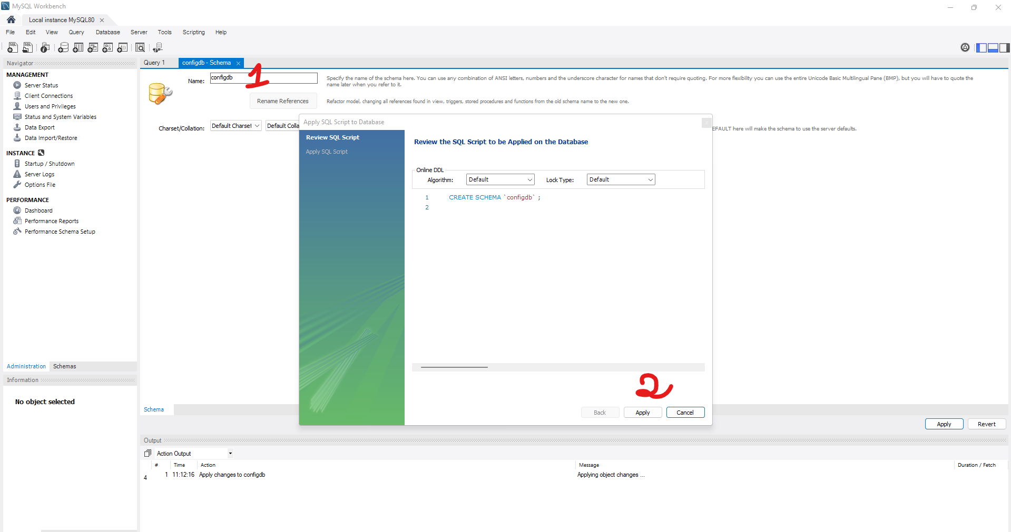

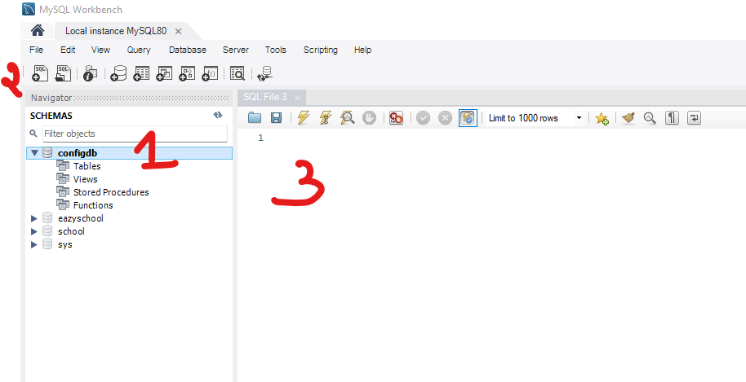

- Is the connection not working , check the cmd+r : services.msc

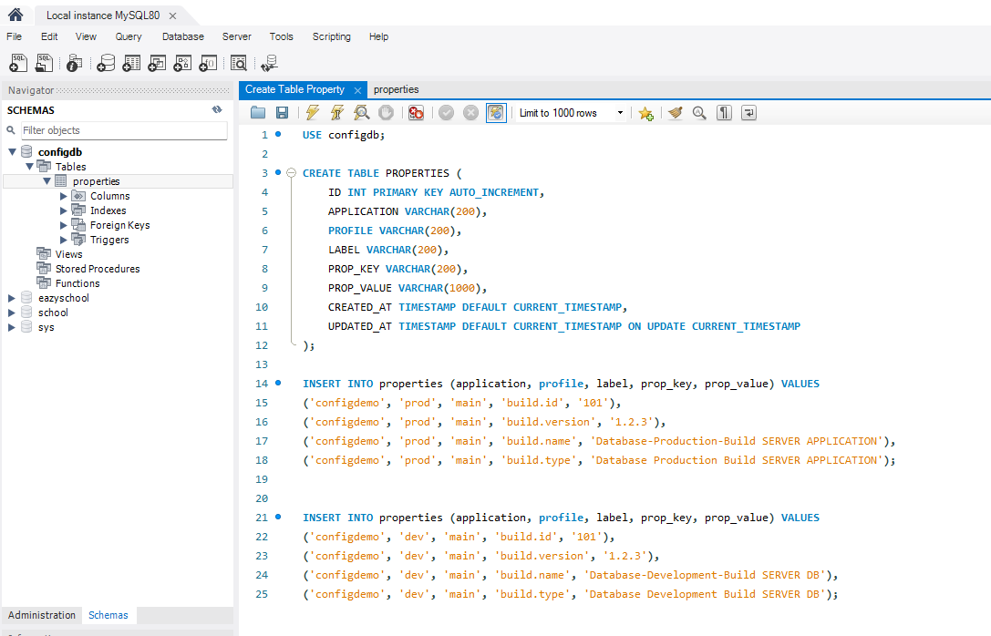

USE configdb;

CREATE TABLE PROPERTIES (
ID INT PRIMARY KEY AUTO_INCREMENT,
APPLICATION VARCHAR(200),
PROFILE VARCHAR(200),
LABEL VARCHAR(200),
PROP_KEY VARCHAR(200),
PROP_VALUE VARCHAR(1000),
CREATED_AT TIMESTAMP DEFAULT CURRENT_TIMESTAMP,
UPDATED_AT TIMESTAMP DEFAULT CURRENT_TIMESTAMP ON UPDATE CURRENT_TIMESTAMP
);

INSERT INTO properties (application, profile, label, prop_key, prop_value) VALUES
('configdemo', 'prod', 'main', 'build.id', '101'),
('configdemo', 'prod', 'main', 'build.version', '1.2.3'),
('configdemo', 'prod', 'main', 'build.name', 'Database-Production-Build SERVER APPLICATION'),
('configdemo', 'prod', 'main', 'build.type', 'Database Production Build SERVER APPLICATION');

INSERT INTO properties (application, profile, label, prop_key, prop_value) VALUES
('configdemo', 'dev', 'main', 'build.id', '101'),
('configdemo', 'dev', 'main', 'build.version', '1.2.3'),
('configdemo', 'dev', 'main', 'build.name', 'Database-Development-Build SERVER DB'),
('configdemo', 'dev', 'main', 'build.type', 'Database Development Build SERVER DB');

SELECT PROP_KEY, PROP_VALUE FROM PROPERTIES WHERE APPLICATION = 'configdemo' AND PROFILE = 'dev' AND LABEL = 'main';

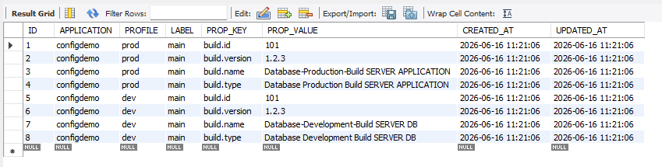

- Add dependency in the config-server
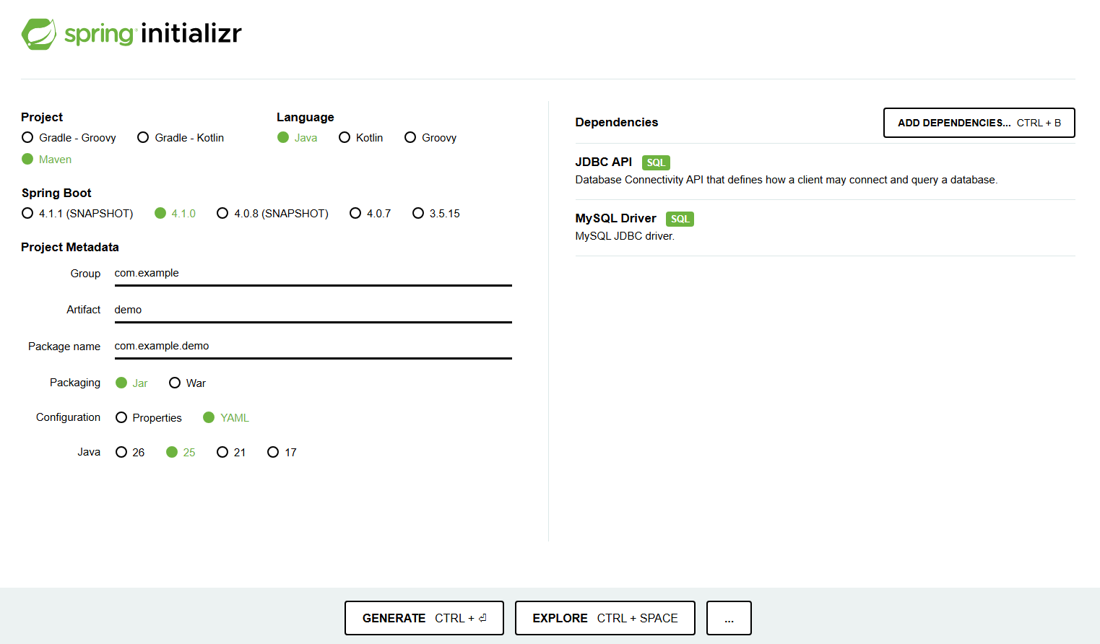

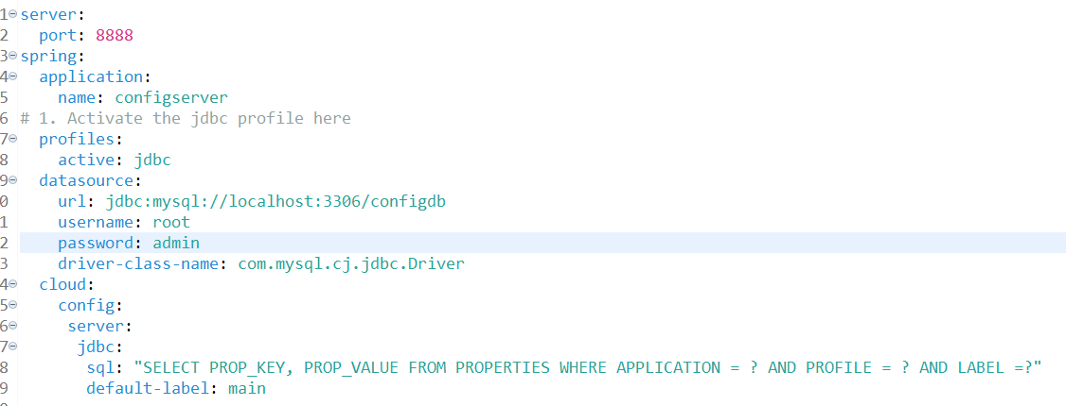

server:
port: 8888
spring:
application:
name: configserver
# 1. Activate the jdbc profile here
profiles:
active: jdbc
datasource:
url: jdbc:mysql://localhost:3306/configdb
username: root
password: admin
driver-class-name: com.mysql.cj.jdbc.Driver
cloud:
config:
server:
jdbc:
sql: "SELECT PROP_KEY, PROP_VALUE FROM PROPERTIES WHERE APPLICATION = ? AND PROFILE = ? AND LABEL =?"
default-label: main

- Importance: we need to # 1. Activate the jdbc profile by default it will get from git hub.
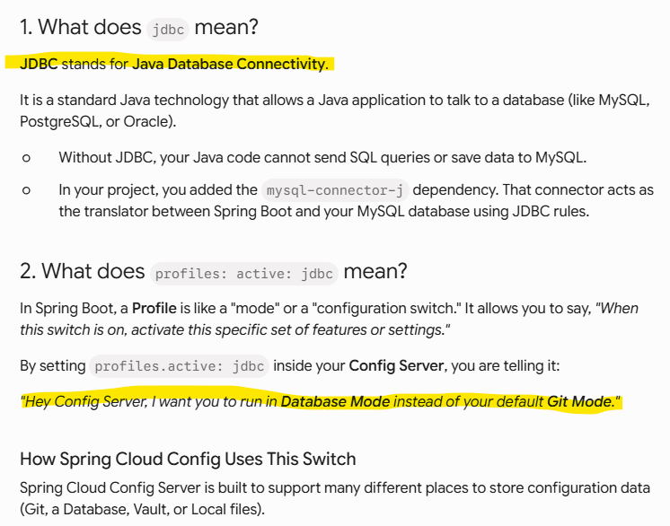

- Client config
- Add dependencies for client

<!-- Spring Cloud Config Client -->
<dependency>
<groupId>org.springframework.cloud</groupId>
<artifactId>spring-cloud-starter-config</artifactId>
</dependency>

- Application.yml
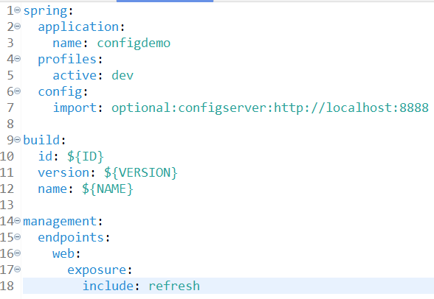

spring:
application:
name: configdemo
profiles:
active: dev
config:
import: optional:configserver:http://localhost:8888

build:
id: ${ID}
version: ${VERSION}
name: ${NAME}

management:
endpoints:
web:
exposure:
include: refresh

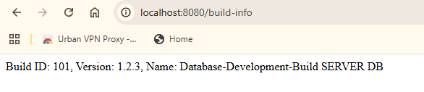

- Setup controller

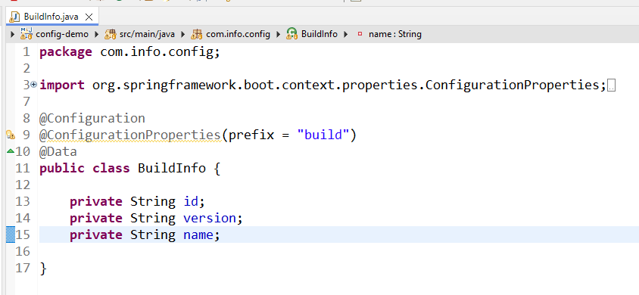

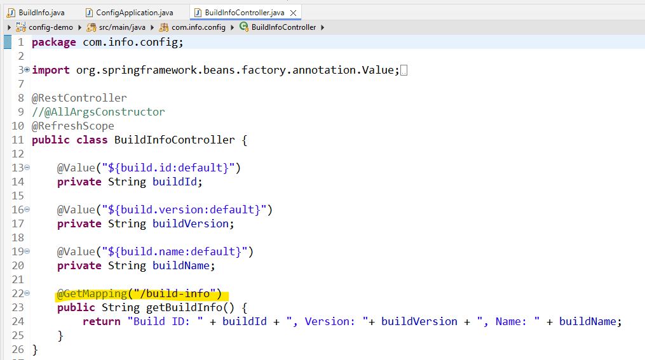

យើងមើលកន្លែង
config:
import: optional:configserver:http://localhost:8888

ជាកន្លែងដែលយើងធ្វើការភ្ជាប់ទៅកាន់ config server
- Log file
